**Border Security Technologies Market Size, Share & Trend Analysis, By Technology, By Component, By End-User, By Application, Regional Outlook, Competitive Tactics, and Segment Forecast to 2030**

**Border Security Technologies Market Overview:**

According to Reports and Insights analysis, the global Border Security Technologies market is estimated to be US$ 4.7 Bn in 2022. Furthermore, the Border Security Technologies market is to register a CAGR of 7.7% which is expected to result in a market forecast value for 2030 of US$ 8.6 Bn.

This market study on the global Border Security Technologies market aims to cover market dynamics such as market drivers, challenges/restraints, and opportunities for the market players. It will also cover market segmentation outlook, Border Security Technologies market trend, regional outlook, Border Security Technologies market size, and market share, as well as industry and product insights, SWOT analysis, Porter's five force analysis, PESTEL analysis, heat map analysis, market forecast, and the major players operating in the Border Security Technologies market.

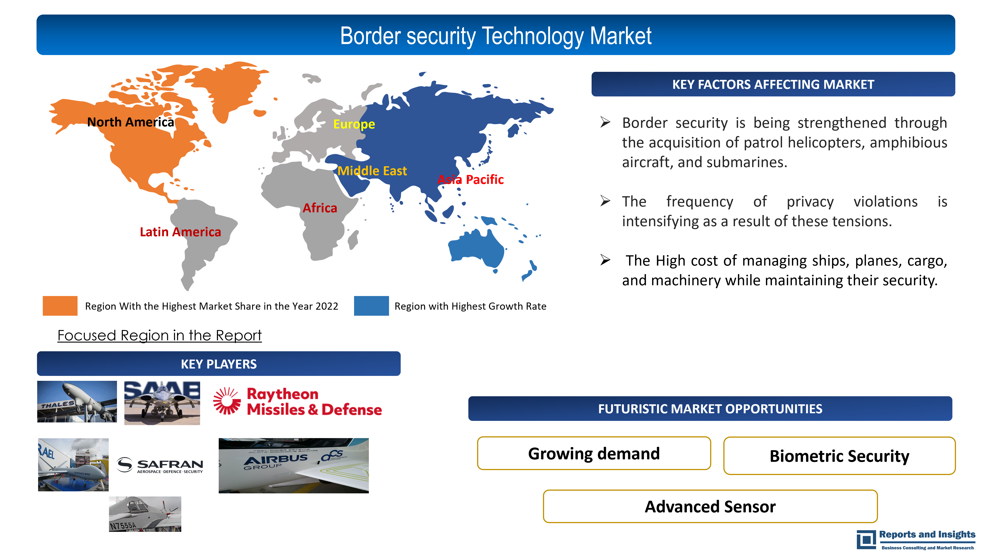

**What is border security technology?**

The Science and Technology Directorate (S&T) makes investments in border security research and development, offers solutions to stop the unauthorized entrance and exit of people, weapons, hazardous materials, and contraband, collaborates closely with border and immigration officers to understand how technology may assist their missions and solve issues, and controls the risks posed by people and products in transit.

**Scope of the Report:**

|  |  |
| --- | --- |
| Report Metric | Report Details |
| Market size available for the years | 2022-2030 |
| Base year | 2021 |
| Forecast Period | 2022-2030 |
| Segments Covered | By Technology, By Component, By Applications, By End-User, By Geography |
| Regions Covered | **North America**  *The U.S., Canada*  **Latin America**  *Brazil, Mexico, Argentina, Rest of Latin America*  **Asia Pacific**  *China, India, Japan, Australia & New Zealand, ASEAN, Rest of Asia Pacific*  **Europe**  *The U.K., France, Spain, Italy, Russia, Poland, BENELUX, NORDIC, Rest of Europe*  **Africa**  *North Africa, Egypt, Rest of Africa*  **The Middle East**  GCC Countries, Israel, Rest of Middle East |
| Key Players | Raytheon Company, Thales, FLIR Systems, Saab, Leonardo, Israel Aerospace Industries, Moog, Controp Precision Technologies, Lockheed Martin Corporation, BAE Systems, Elbit Systems, Northrop Grumman Corporation, Safran, Rockwell Collins, Airbus Group. |

**Border Security Technologies Market Dynamics**

The border security system is a sophisticated autonomous security system with precise results and a great range.

**Market Drivers**

***“Growing worry over data breaches is mostly driving industry expansion”:***

The need for border security is anticipated to rise as a result of geopolitical unrest and regional wars. The frequency of privacy violations is intensifying as a result of these tensions.

***“Rise in terrorist activities”:***

The rise in global terrorist activities has led to an increased demand for advanced border security technologies to detect and prevent terrorist activities at borders. Additionally, border security is being strengthened through the acquisition of patrol aircraft, observation aircraft, assault helicopters, amphibious aircraft, and submarines.

**Market challenges**

***“High production and installation costs”:***

The expense of allowing security officers and workers to watch video screens around-the-clock during regular hours, as well as the cost of managing ships, planes, cargo, and machinery while maintaining their security, are all considered. Additionally, this entails fees for maintenance and training, which are crucial while using the equipment in hostile circumstances. A significant upfront expenditure is needed to implement and maintain border security technology including surveillance, detection, survey, and warning systems.

The software license price, installation, maintenance, modification, and training are other factors contributing to the high cost of border security systems. Most market players provide local border control solutions, allowing ports to cover all expenditures, including those for infrastructure, maintenance, and other charges.

**Market Opportunities**

***“Growing demand for unmanned vehicles”:***

In a range of military uses, unmanned vehicles are growing in popularity. Drones have been used by national defense forces all around the world for more than a decade. UGVs, UUVs, and UAVs are all used for a variety of tasks, including mapping and surveying, aerial photography and videography, asset inspection, search and rescue operations, exploration, and emergency response.

***“Biometric Security Solutions”:***

Biometric technology uses unique physical characteristics, such as fingerprints, facial recognition, and iris scans, to verify a person's identity. Implementing biometric security solutions at border crossings can help prevent identity fraud and improve border security. There is a growing demand for advanced biometric systems that can quickly and accurately identify individuals and verify their travel documents.

***“Advanced Sensor Technologies”:***

Advanced sensor technologies can provide border patrol agents with real-time situational awareness, allowing them to quickly detect and respond to potential threats. For example, radar systems can detect movement and identify objects at long distances, while acoustic sensors can detect and classify different types of sounds, such as gunshots, explosions, or vehicle engines. Integrating these technologies into a comprehensive border security system can enhance border patrol capabilities and improve safety for both border agents and travelers.

**Border Security Technologies Market Segmentation Outlook**

The market is divided into three categories depending on the environment: ground, aerial, and naval. The market is further divided into many categories based on the system: laser, radar, camera, wideband wireless communication, perimeter intrusion, unidentified vehicles, and biometric systems. The market is divided into four regions based on geography: North America, Europe, Asia Pacific, and the rest of the world.

**By Component:**

* Hardware
* Software
* Services.

**By Technology:**

* + Biometrics
  + Cameras
  + Surveillance
  + Communication systems
  + Radiation detectors

and others.

**By** **Application:**

* Land border security
* Coastal border security
* Air border security

**By End-User:**

* Government Agencies
* Military
* Border Control Authorities

**By Geography:**

* North America
* Latin America
* Asia Pacific
* Europe
* Middle East
* Africa

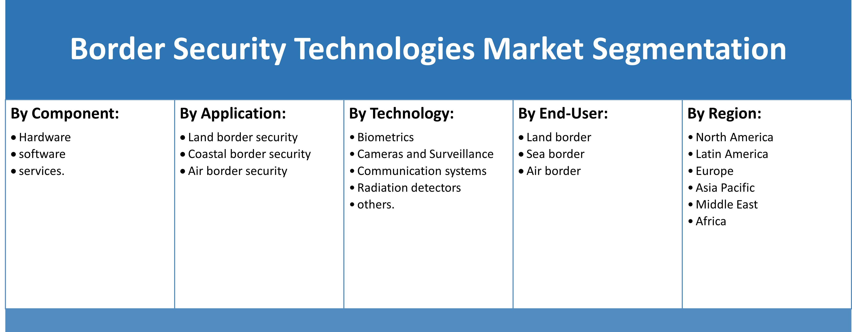

**Border Security Technologies Market Regional Outlook**

The target market is expanding in this region due to reasons including increased military spending and the use of cutting-edge technology, particularly in the United States. The significant expenditure on research and development in the military industry is another trend that is anticipated to increase demand in the North American target market.

Currently, the Asia-Pacific region holds the biggest market share for border security. This is mostly because of the continuous border conflicts between China and Japan, India and Pakistan, and India and China. China, one of the biggest nations in Asia, is at odds with Taiwan, India, North Korea, Malaysia, South Korea, Indonesia, Japan, the Philippines, and Vietnam over territorial disputes.

**Border Security Market Recent Technologies:**

Biometric Entry/Exit: At the start of 2020, The U.S. Customs and Border Protection (CBP) expanded its facial recognition technology at airports to enhance border security and facilitate travel. This technology uses biometric data to verify the identity of travelers entering and exiting the country.

AI-based surveillance: Some countries have started using artificial intelligence (AI) by the mid of 2020, to detect suspicious behavior and potential threats at borders. For instance, the EU-funded iBorderCtrl project uses AI-based lie detection technology to screen travelers at select border checkpoints.

Blockchain-based identityverification: Blockchain-based identity verification technology is being explored by some border security agencies to enhance security and prevent identity fraud. For example, the World Economic Forum and the governments of Canada and the Netherlands have collaborated on a pilot project that uses blockchain to securely verify travelers' identities.

* IBM and the U.S. Department of Homeland Security (DHS): In 2020, IBM announced a collaboration with the DHS to develop a blockchain-based platform to improve border security and prevent cross-border threats. The platform will use IBM's cloud and blockchain technology to securely share information between different government agencies.
* Palantir Technologies and the U.S. Customs and Border Protection (CBP): In 2019, Palantir Technologies, a data analytics company, signed a contract worth $43 million with the CBP to provide its data management platform for border security operations. The platform allows CBP agents to access and analyze data from multiple sources in real time to identify potential security threats.
* Thales and the Qatar Ministry of Interior: In 2020, Thales announced a partnership with the Qatar Ministry of Interior to provide a biometric identification system for the country's border security operations. The system includes facial recognition, iris recognition, and fingerprint recognition technologies.
* Thales, a France-based defense manufacturer signed an agreement with DEFEND ID I to support the modernization of Indonesian defense equipment in November 2022. Thales signed a joint venture partnership with PT Len for the maintenance, repair, and overhaul of radars of the Indonesian air force.
* In November 2022, BAE Systems announced that it received a lucrative grant to manufacture the next five city-class type 26 warships for the Royal Navy in Glasgow. This contract will allow BAE systems to produce 4000 new jobs in the company. Type 26 is one of the most advanced types of warships right now.